1.DRAWN GAMES

1. Draw game by mutual consent
A player may offer a draw after completing his move. His opponent may accept or decline it.
2. Insufficient material to checkmate
If one side has King and a Bishop or a Knight versus a lone King then the game is draw.
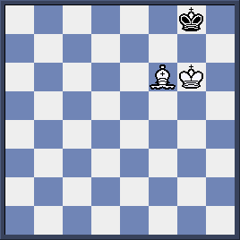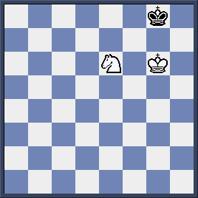

Stalemate
A stalemate occurs when a player whose turn to move has no legal moves to make.

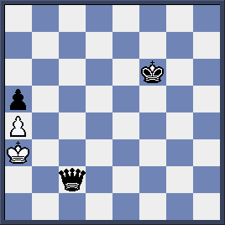
White has turn to move. However, his King and pawn are unable to move legally.

The same situation occurs here. His pawns are blocked, his Rook is pinned and his King cannot play a single legal move.
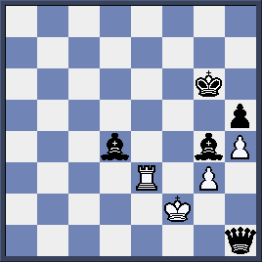

3.Repetition of moves
- Threefold repetition of position:
If the same position on the board is repeated three times then a player can claim a draw.

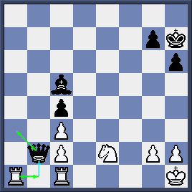

White plays 1. ab1 to attack Black Queen. Black has no choice but retreat Queen to a3.

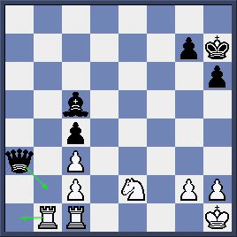

White keeps on chasing Queen with 2. a1 and again Black forces to move Queen back to b2.The position then repeats 3 times and the game is draw.

- Perpetual check:
If one side keeps on checking and his opponent has no way to change the situation then the game is also draw.

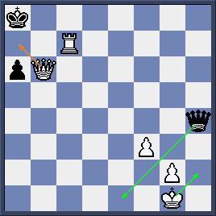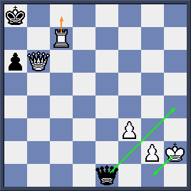

White is about to checkmate, however it is Black’s turn. He saves the game by checking continuously at e1 and h4. White King can do nothing except moving back and forth from g1 to h2. Game is draw by perpetual check.
4. 50-move rule
If both sides play continuously 50 moves without any capture or pawn move, a player can claim a draw.

